|  |
| --- |
| stafford Universirty |
| Individual Design Report |
| Mobile Multimedia & Gaming: CE00342-6-030112-070412 |
|  |
| **Alex J Davison** |
| **04/02/2012** |

|  |
| --- |
| This document outlines the design of one game application for a generic mobile deviceand one none game application for two different mobile platforms. |

Contents

Introduction 1

Smart Phone Game 1

Game Play 4

Game interface logic 5

Mock-Up 6

Smart Phone Application 13

Mock-Up/Mobile interaction/Media Content 13

iPhone 13

Windows 7 Phone 20

Table of figures 27

Bibliography 28

# Introduction

This document outlines the design for a game application on a generic smart phone and the design for an application on two different mobile devices, one being the iPhone and the other being the Windows Phone 7.

# Smart Phone Game

The following section of this report is for the game application. The game is called “Hammy the hamster’s roller ball adventure!” which has been designed for developed on any smart phone.

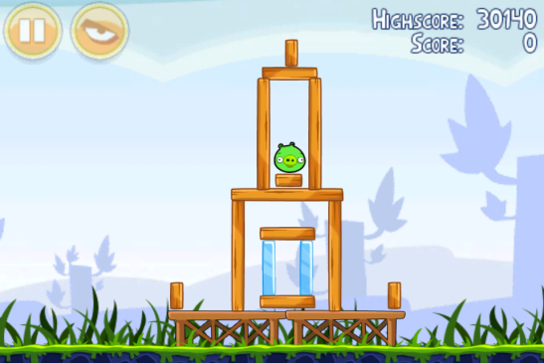

Figure 1 - Angry birds (Mobile, 2009)

Learnability of the application will be achieved by keeping the interface to the game simple. The application will be consist with other game that have been developed. Game play will use the gyroscopic properties that most smart phones have so that there is no complex interfaced to use. Players move their phones by roll, yaw and pitch of the phone to move the player’s character.

Simplicity of the game is due to its target audience of children. Simplicity of the game and efficiency use of the mobile device’s attributes will maximise the user’s experiences. The character will be brightly coloured for high visibility and to attract a large target audience. The character will also have a voice over for the character, this makes the character and game have a memorability factor for future possible sequels of the game also a questionable ending will leave the game open for a sequel.

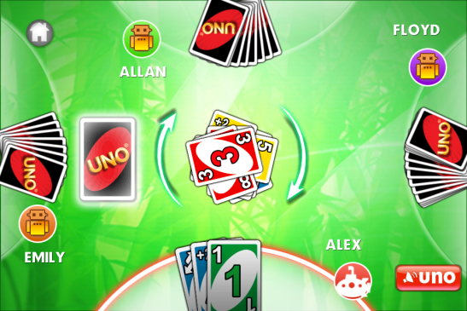

Figure 2 – Uno (Loft, 2008)

The game state will change when the phone receives a message and/or other event that by another application, the game state will be paused until the other application is resumed by the user. Mapping the controls will be similar other game applications found on the market, such as keeping the game either in landscape or portrait such as games depicted in, Figure 2 – Uno (Loft, 2008), Figure 3 – The Heist (Inc, 2011) and Figure 4 – Trainyard (Rix, 2011).

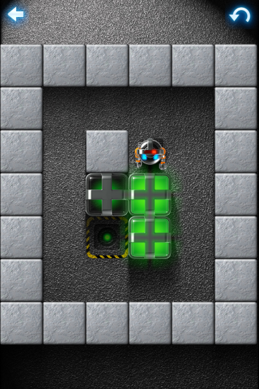

Figure 3 – The Heist (Inc, 2011)

Mapping and the visibility of the controls at clearly defined points within the game will help users find and use them. As you can see from the Figure 3 – The Heist (Inc, 2011) the use of arrows has been used to show the user how to reset the game and return to home page. This consistency will be carried out through the game that will be developed. Like other games feedback will be given about the player score through messages and satisfaction will be achieved through betting the player own score like in arcade games.

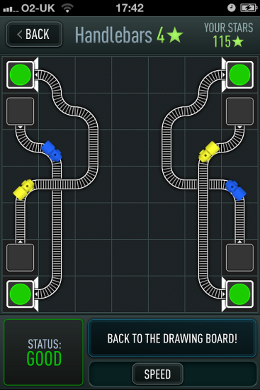

Figure 4 – Trainyard (Rix, 2011)

## Game Play

Game play is based upon the story on Hammy the hamster who is hungry hamster on the looking out for some food. Hammy sees a carrot and gets into his hamster ball to travel to get to the carrot. Unknowingly Hammy enters a maze to obtain the carrot. When Hammy enters the maze the door shuts and locks. Hammy must navigate through the maze and collect carrot/food as Hammy goes through the maze.

The game will have introduction video that will play out the story board as shown in Figure 5 - Story board. This will have a game theme track playing in the background with game sound effects to be played with actions within the animation.

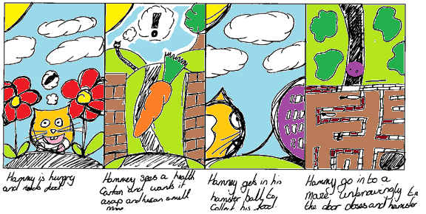

Figure 5 - Story board

## Game interface logic

The interface logic for the game is as follows.



Figure 6 - Game logic

## Mock-Up

This section of the report outlines the mock ups for the screens that be used in the game. Figure 7 - Video Screen show the mock up for introduction video for the game. As you can see the video will play full screen and have no interaction icon and/or interface.



Figure 7 - Video Screen

Figure 8 - Game Menu shows the main menu for the game. As you can see from Figure 8 - Game Menu there are three main buttons Start Game, High Score and Exit. The only other enforces is to ensure that the title of the game is visible above the buttons. Note that navigation can be used either touch or using buttons to select an item. The use of three interface buttons Play, High Score and Exit on the main menu will keep it simple.

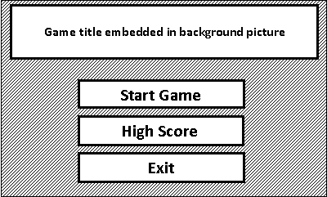

Figure 8 - Game Menu

Figure 9 - HUD Screen over layer of game play show the HUD (Heads Up Display) for the game. The HUD is laid over the game. The circular component in the bottom right hand corner is used for devices that do not have button input and no gyroscopic motion monitoring. The game will have a pause image in the top left hand corner and simple text in the right hand corner to allow the user to know how much time they have remain and their score.

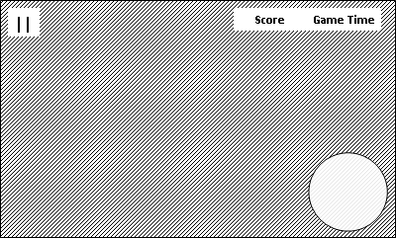

Figure 9 - HUD Screen over layer of game play

The player must move Hammy using the gyroscope properties of a smartphone using the accelerometer. However if the smartphone has not got an accelerometer then the application can adapt and a joystick type interface such as the one found in Figure 10 - Simpson Game (Arts, 2010) can be used. A close up can of the interface be found in Figure 10 - Simpson Game (Arts, 2010)

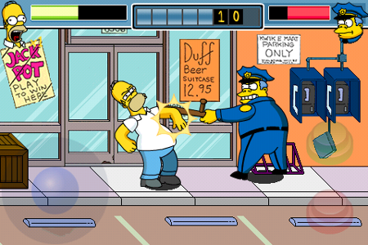

Figure 10 - Simpson Game (Arts, 2010)

If the smart phone does not have a touch screen or accelerometer then button interface can be used.

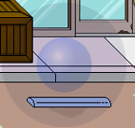

Figure 11 - Simpson’s Joystick (Arts, 2010)

Game logic can be found in Table 2 - Game Logic.

Table 1 - Game play key

|  |  |
| --- | --- |
| Icon | Key |
|  | Player |
|  | Wall |
|  | Finish area |
|  | Food (Points) |

Table 2 - Game Logic

|  |  |  |  |  |
| --- | --- | --- | --- | --- |
|  |  |  |  |  |
|  | X |  |  |  |
|  | Player collides with wall | X |  |  |
|  | Player finishes games | X | X |  |
|  | Player scores point | X | X | X |

Figure 12 - Game playshows the kind of game play to be expected in 2D. Note that the game is to be made using 2.5D. When the player hits the carrots/food items a sound will be played. A sound track will be in the background, as player’s time starts to run out the sound track will speed up. Other animations could be introduced for getting the top score. The player must navigate the maze and collect the carrots/food which has an accumulative score will increase, the fast the player completes the maze the remaining time in seconds is added to the player score. The player must chose speed over collecting items to get the best score. The player is then added to the top five if they have beat the current lead board players.

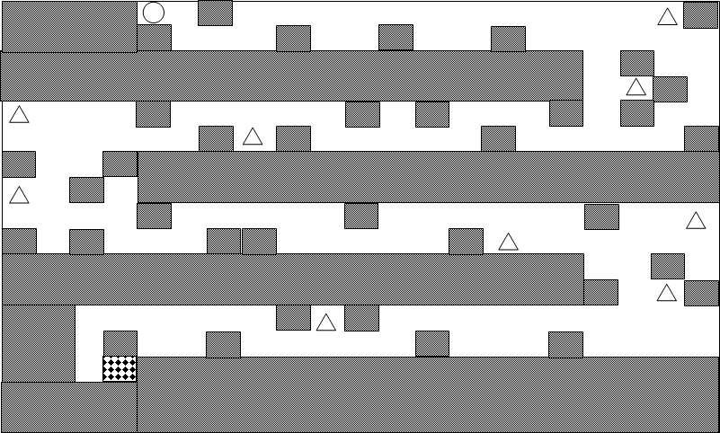

Figure 12 - Game play

Figure 13 - Pause screen shows the paused screen for when either the player or another application has interrupted the game. There are only two buttons, one to exit the game and the one to continue the game.

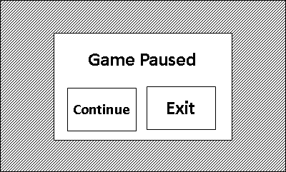

Figure 13 - Pause screen

Figure 14 - Score message shows the player what their score was at the end of the game.

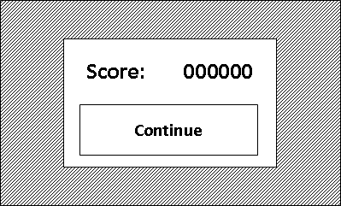

Figure 14 - Score message

Figure 15 - High score input shows a message box that will appear for the player to input their name if they are in the top five. The keyboard on the screen is optional according to the platform that the game will be played on.

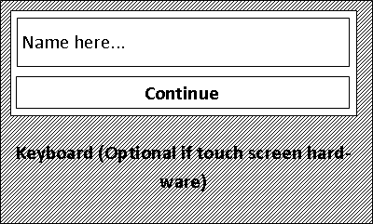

Figure 15 - High score input

Figure 16 - High score screen shows the high score screen. This data will be saved on the phone. There will be only on button to return to the main menu.

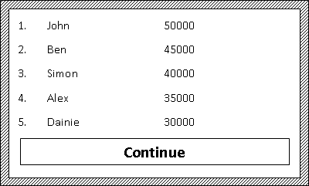

Figure 16 - High score screen

# Smart Phone Application

The following section of the report outlines an application for the London 2012 Olympics application. This application is designed for the iPhone and for the Windows 7 phone. The application is designed to inform avid fans about the Olympics in 2012. The application is designed to allow user to find out about the UK team. The application is designed to allow the user to know how long unit the Olympics and what and when events are on.

## Mock-Up/Mobile interaction/Media Content

The following section is broken in to two sections, one for the iPhone and the other for the Windows 7 phone.

### iPhone

This section shows the design for the iPhone. Figure 17 - iPhone load screen show the load screen for the application on the iPhone. There is no interaction at this point. There is only the Olympic picture of the logo and the London stadium.

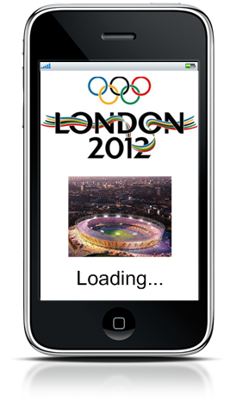

Figure 17 - iPhone load screen

Figure 18 - iPhone members screen shows first. At the bottom of the screen is a bar showing the three main sections of the application, the UK team, events and the countdown. The user taps on either a team member to view their detail or on a button on the bottom of the screen. The user can borrows the list of members by drag his or her finger up and the down the list.

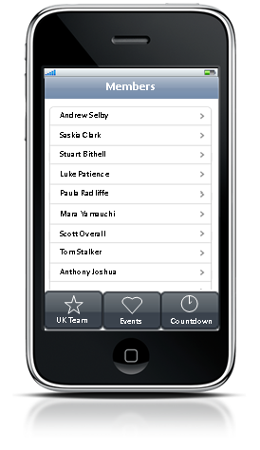

Figure 18 - iPhone members screen

Figure 19 - iPhone picture screen shows the picture of the member selected. This allows the users to view the member of the team that they have selected. This is the screen that they will see once the user has selected a member. The user can navigate through information about the member by using the tool bar at the top, alternatively selected a different user by going back.

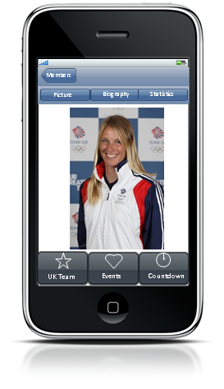

Figure 19 - iPhone picture screen

Figure 20- iPhone biography screen shows the biography of the team member. The user can scroll through the information by dragging their finger up or down the screen.

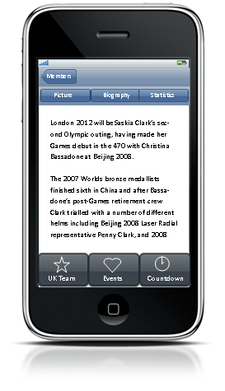

Figure 20- iPhone biography screen

Figure 21 - iPhone statistics screen shows the statistical information about the member of the team member. The user can scroll through the information by dragging their finger up or down the screen.

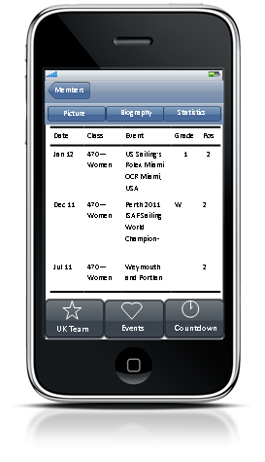

Figure 21 - iPhone statistics screen

Figure 22 - iPhone event finder screen shows the screen that the user can user to filter the events that are stored on the phone.

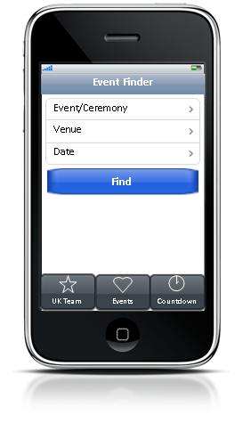

Figure 22 - iPhone event finder screen

Figure 23 - iPhone event filter screen shows how the user can filter by event the user selects an event and by taping it. The user can scroll through the information by dragging their finger up or down the screen.

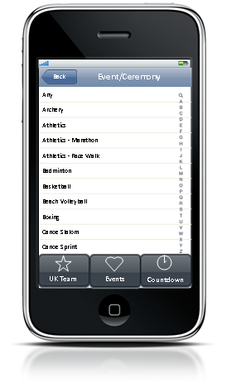

Figure 23 - iPhone event filter screen

Figure 24 - iPhone venue screen shoes how the user can filter by venue. The user can scroll through the information by dragging their finger up or down the screen.

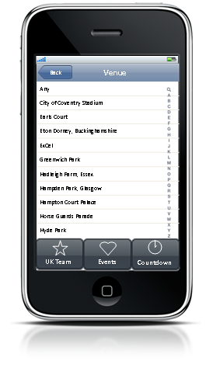

Figure 24 - iPhone venue screen

Figure 25 - iPhone date screen shows where the user can filter by date. The user can scroll through the information by dragging their finger up or down the screen.

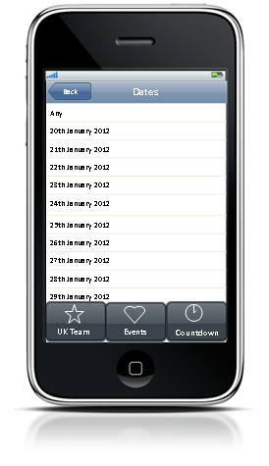

Figure 25 - iPhone date screen

Figure 26 - iPhone event screen shows the list of events. After the user has tapped find from Figure 22 - iPhone event finder screen. The user can scroll through the information by dragging their finger up or down the screen.

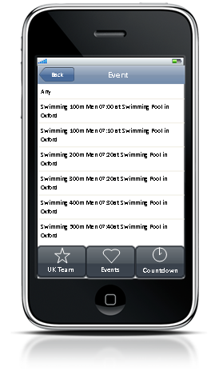

Figure 26 - iPhone event screen

Figure 27 - iPhone countdown screen shows the countdown clock unit the Olympics start. The countdown updates in real time.

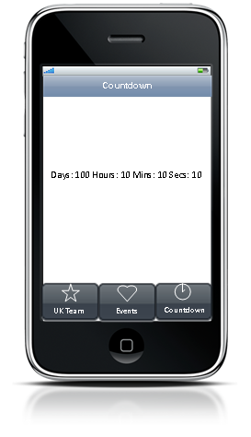

Figure 27 - iPhone countdown screen

### Windows 7 Phone

This section of the report outlines the Windows 7 phone design. Figure 28 – Windows phone home screen show how the user can select a section of the application. Button input and or touch depending on the in phone model will allow the user to select the items in this design. The Olympics image will be used.

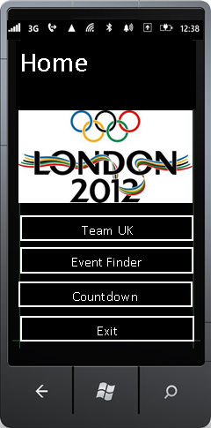

Figure 28 – Windows phone home screen

Figure 29 – Windows phone team UK finder screen shows how a member of the UK team can be filtered.

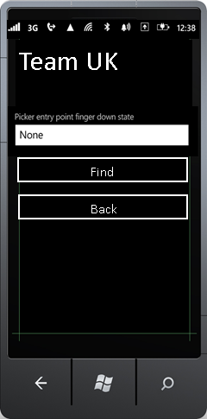

Figure 29 – Windows phone team UK finder screen

Figure 30 – Windows phone member screen shows the selection process. The user can scroll through the information by dragging their finger up or down the screen.

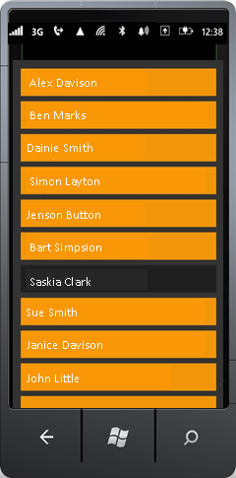

Figure 30 – Windows phone member screen

Figure 31 – Windows phone bibliography screen shows the member selected biography and picture. This will allow screen shows after the find button has been selected.

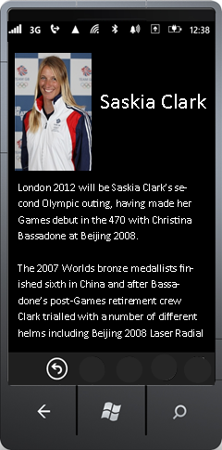

Figure 31 – Windows phone bibliography screen

Figure 32 – Windows phone statistic screen shows the user scrolling down and looking at the statistics this is a continuation from Figure 32 – Windows phone statistic screen.

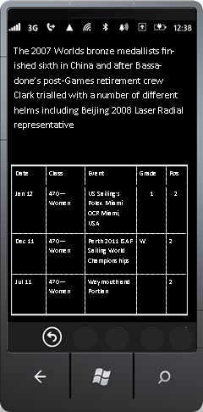

Figure 32 – Windows phone statistic screen

Figure 33 – Windows phone event select screen shows how the user would filter the events.

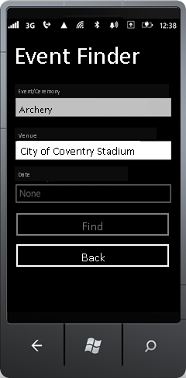

Figure 33 – Windows phone event select screen

Figure 34 – Windows phone event select screen shows how to apply a filter the events. The user can scroll through the information by dragging their finger up or down the screen.

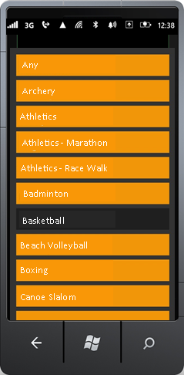

Figure 34 – Windows phone event select screen

Figure 35 – Windows phone venue select screen shows how to apply a filter the venue. The user can scroll through the information by dragging their finger up or down the screen.

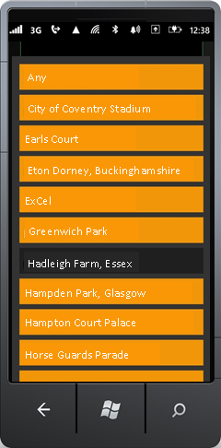

Figure 35 – Windows phone venue select screen

Figure 36 – Windows phone date select screen shows how to apply a filter the dates. The user can scroll through the information by dragging their finger up or down the screen.

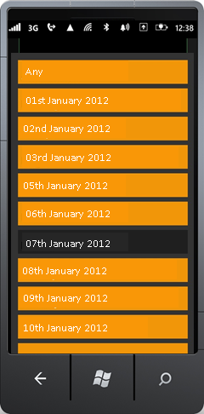

Figure 36 – Windows phone date select screen

Figure 37 – Windows phone event screen shows the results of the filter. The user can scroll through the information by dragging their finger up or down the screen.

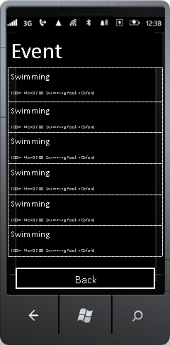

Figure 37 – Windows phone event screen

Figure 38 – Windows phone countdown screen shows the countdown clock. The countdown will update in real time.

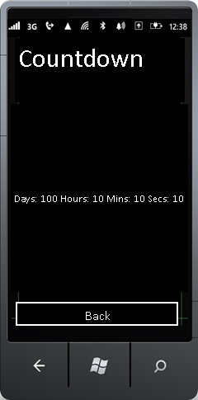

Figure 38 – Windows phone countdown screen

# Table of figures

Figure 1 - Angry birds (Mobile, 2009) 2

Figure 2 – Uno (Loft, 2008) 2

Figure 3 – The Heist (Inc, 2011) 3

Figure 4 – Trainyard (Rix, 2011) 3

Figure 5 - Story board 4

Figure 6 - Game logic 5

Figure 7 - Video Screen 6

Figure 8 - Game Menu 7

Figure 9 - HUD Screen over layer of game play 8

Figure 10 - Simpson Game (Arts, 2010) 8

Figure 11 - Simpson’s Joystick (Arts, 2010) 9

Figure 12 - Game play 10

Figure 13 - Pause screen 11

Figure 14 - Score message 11

Figure 15 - High score input 12

Figure 16 - High score screen 12

Figure 17 - iPhone load screen 13

Figure 18 - iPhone members screen 14

Figure 19 - iPhone picture screen 15

Figure 20- iPhone biography screen 15

Figure 21 - iPhone statistics screen 16

Figure 22 - iPhone event finder screen 17

Figure 23 - iPhone event filter screen 17

Figure 24 - iPhone venue screen 18

Figure 25 - iPhone date screen 18

Figure 26 - iPhone event screen 19

Figure 27 - iPhone countdown screen 19

Figure 28 – Windows phone home screen 20

Figure 29 – Windows phone team UK finder screen 21

Figure 30 – Windows phone member screen 22

Figure 31 – Windows phone bibliography screen 23

Figure 32 – Windows phone statistic screen 23

Figure 33 – Windows phone event select screen 24

Figure 34 – Windows phone event select screen 24

Figure 35 – Windows phone venue select screen 25

Figure 36 – Windows phone date select screen 25

Figure 37 – Windows phone event screen 26

Figure 38 – Windows phone countdown screen 26

# Bibliography

Arts, E. (2010) *The Simpsons Arcade*, Apple.

Inc, I. (2011) *The Heist*, Apple.

Loft, G. (2008) *Uno*, Apple.

Mobile, R. (2009) *Angry Birds*, Espoo, Finland: Chillingo/Clickgamer.

Rix, M. (2011) *Trainyeard*, Apple.

Train4tradeSkills (2011) *Train4tradeSkills*, Oct, [Online], Available: <http://train4tradeskills.wordpress.com/2011/10/11/train4tradeskills-news-for-sale-one-olympic-stadium/> [03 Feb 2012].

Villamor, C., Willis, D. and Wroblewski, L. (2010) 'Touch Gesture Refernce Guide', Apr, p. 1.

Woodard, R. (2012) *Decanter.com*, 19 Jan, [Online], Available: <http://www.decanter.com/news/wine-news/529674/london-olympics-to-generate-300m-for-wine-trade-says-study> [03 Feb 2012].